14

The Mission of the Church | Acts 1:1-11
Pastor Bill Curtis | January 14, 2018

Sermon Notes
- God gives us power for _________.
- God gives us power for _________.
- God gives us power for _________.

Journey Group Questions
- The Book of Acts records one of three accounts of the Lord’s final commissioning of the apostles. The other two are found in Luke 24:44-53 and Matthew 28:16-20. Each of these accounts gives us additional insight into our mission as a church. Read these texts and answer the following.

- What insights do these texts give us into the full message and mission of the church?

- What part do we as individual believers play in the fulfillment of the mission of the church?

- How is the authority of Christ (Matthew 28:18) related to the mission of the church and why is this truth helpful as we strive to live missionally in our culture today?

- Review the L.I.F.E. acronym that we were given on Sunday. While many of us know the message of the gospel summarized on this card, we have a tendency not to share it with those around us.

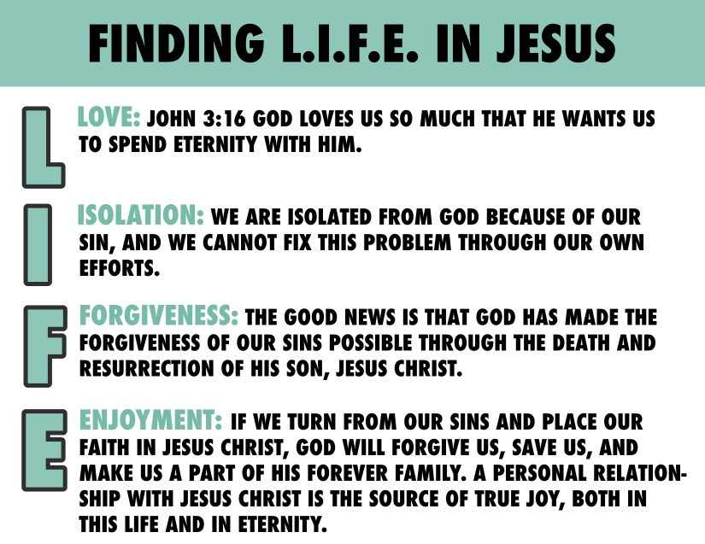
- What often hinders us from sharing this message?

- How do the principles found in our study this week help us to overcome these hindrances?

- List at least three family members, friends, or acquaintances that you can begin to pray for, as you trust the Lord for opportunities to share the good news of the gospel in your
daily life. Pray for them as a part of your group time this week.

