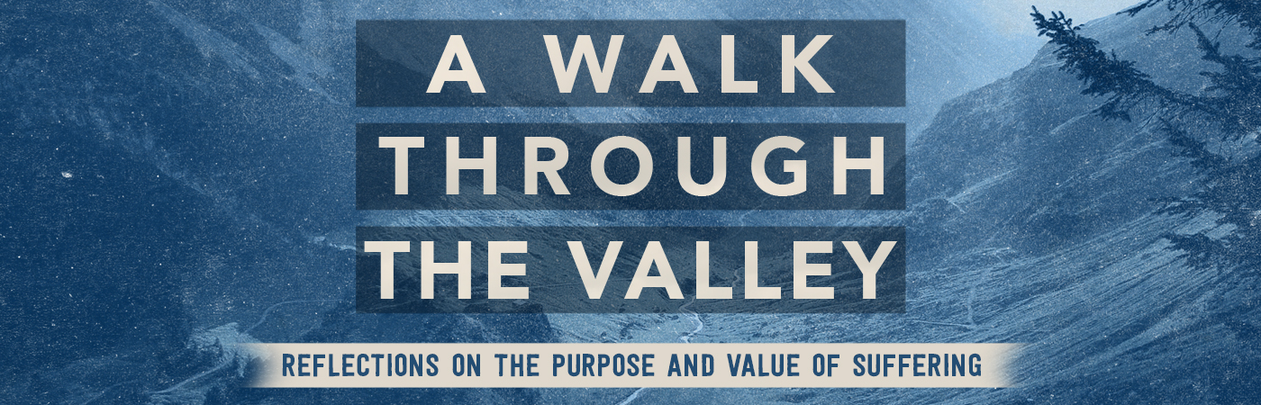

Trusting God in the Valley | Psalm 23:4

Pastor Keith Thompson | July 2, 2017

Sermon Notes

- We trust God in the valley because of His .

- We trust God in the valley because of His .

