Honoring God with Our Money – Generosity

Proverbs 11:24-25 | Pastor Bill Curtis | June 18, 2017

Sermon Notes
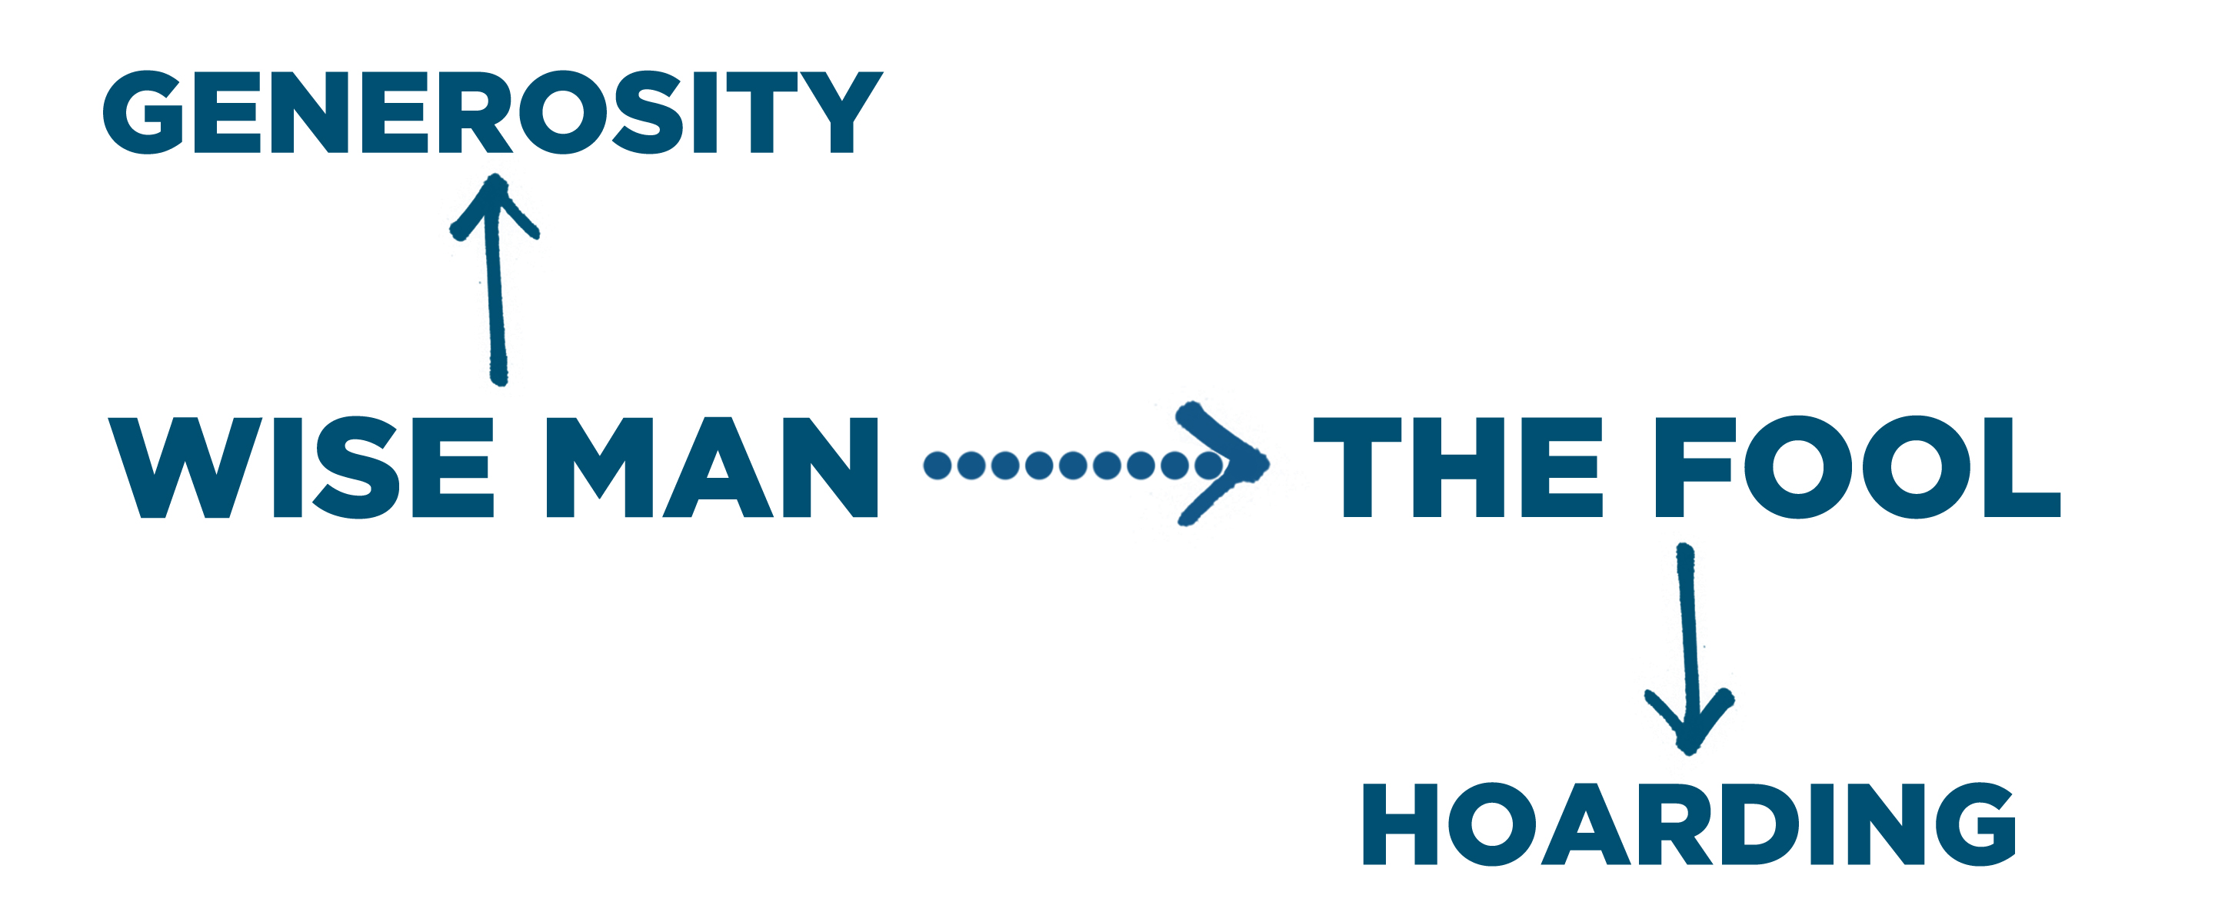

Generosity: Sharing because you fear the
Lord.

1. Financial generosity is a principle.

2. Financial generosity is an evidence of authentic .

Process:

- Tithe: involuntary kingdom gifts; first 10% of every dollar;

- Offering: voluntary kingdom gifts above the tithe;

Guidelines:
- Look for opportunities to be generous with ministry and mission endeavors;
- Look for opportunities to be generous with brothers/sisters in Christ with legitimate financial needs;
- Look for opportunities to be generous with neighbors who have legitimate financial needs;
- Always attempt to give anonymously so that you keep your reward in heaven!

