Wisdom and Priorities | Proverbs 4:23-27 | Pastor Keith Thompson | May 21, 2017

Sermon Notes
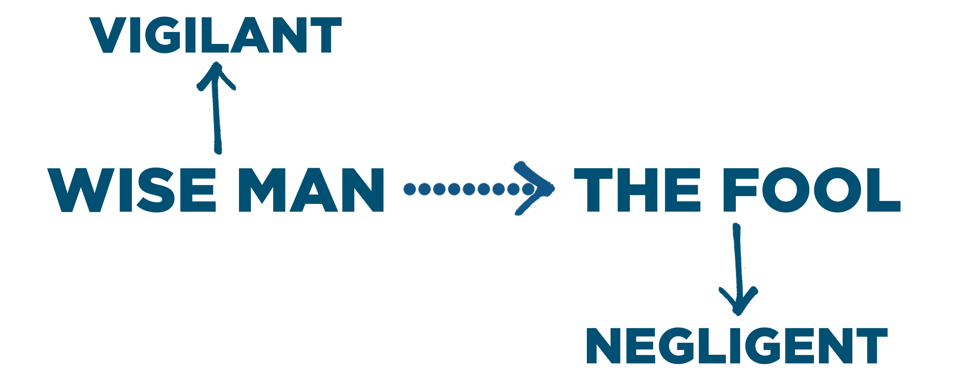
- Vigilance: Guarding your , because you fear the Lord.
  - Vigilant people guard their (4:24).
  - Vigilant people guard their (4:25).
  - Vigilant people guard their (4:26-27).
Journey Group Questions
Being vigilant requires paying careful attention to your journey. As Christ-followers, our value system should be shaped by our Lord, His Word, and His ways. And, our priorities are shaped by our values, whether we are aware of this undeniable truth, or not. Read Ephesians 5:15 and Proverbs 4:23-27 and reflect upon Sunday’s sermon, and answer the following questions.
- According to Eph 5:15, describe the way a believer should conduct his journey of faith. And, how can you be more vigilant on your journey?

- Who, or what, do you value most? (persons, tasks, material things, concepts, organizations, etc.)

- Are all of the items on your most valued list consistent with the values of Scripture? If not, what adjustments to your value system need to be made?

- Now rank the items on your most valued list. Put an “A” next to the one single item you value highest on your list.

- Put a “B” next to a set of items that have very high value to you, but are not THE highest valued item.

- Put a “C” next to all the rest of the items on your list.

- To what degree does your ranking of highly valued items align with the teachings of Scripture? If not aligned well, what adjustments to your value system need to be made?

- What does this exercise tell you about what your priorities should be, and how you could be more vigilant to guard them?

