Wisdom and Encouragement | Proverbs 25:11 | Pastor Keith Thompson | May 7, 2017

Sermon Notes
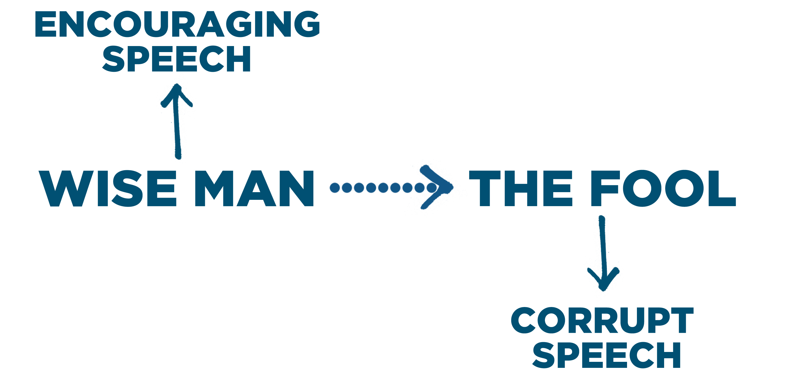
Encouraging Speech: Speaking because you fear the Lord.
  - Encouraging speech says the right at the right (Proverbs 25:11; 10:20; 20:15).

  - Encouraging speech extends and promotes Proverbs 10:21, 31; 11:9; 15:2; 16:23).

  - Encouraging speech reduces and fosters (Proverbs 12:25; 15:4).

  - Encouraging speech turns potential into personal (Proverbs 15:1; 12:18).

  - Encouraging speech produces a for life (Proverbs 10:11).
  - Encouraging speech results in personal (Proverbs 12:14; 13:2).
Journey Group Questions

- As you reflect upon our study this week, when or where have you encountered corrupting/destructive speech in your daily life? Likewise, when have you been blessed by the gracious or encouraging speech of others?

- Read Col 3:5-17, which contrasts the “old self” with the “new self” and connects not only our words, but also our attitudes and actions, to the current state of our hearts as believers in Christ. As you consider this text, answer the following questions.
  - List the sinful desires (v.5) and attitudes/actions (v. 8-9a) that characterize the old self and are to be “put off” or “put to death” according to these verses. What is the relationship between these two lists?

  - What does this tell us about the source and underlying cause of sinful actions, attitudes, and speech in our lives?

  - How does putting on the new self effectively transform our attitudes, actions, and ultimately our speech?

  - If putting on the new self is the key overcoming sin in our lives, including sinful speech, how does one go about putting on the new self?

- What do you need to do specifically this week to more intentionally put on the new self and thereby walk in righteousness?

- How can you use your words intentionally this week to encourage or build up others in your family, work, school, church, or community?

