Wisdom and Stability | Proverbs 29:20; 21:23
Pastor Bill Curtis | April 30, 2017

Sermon Notes
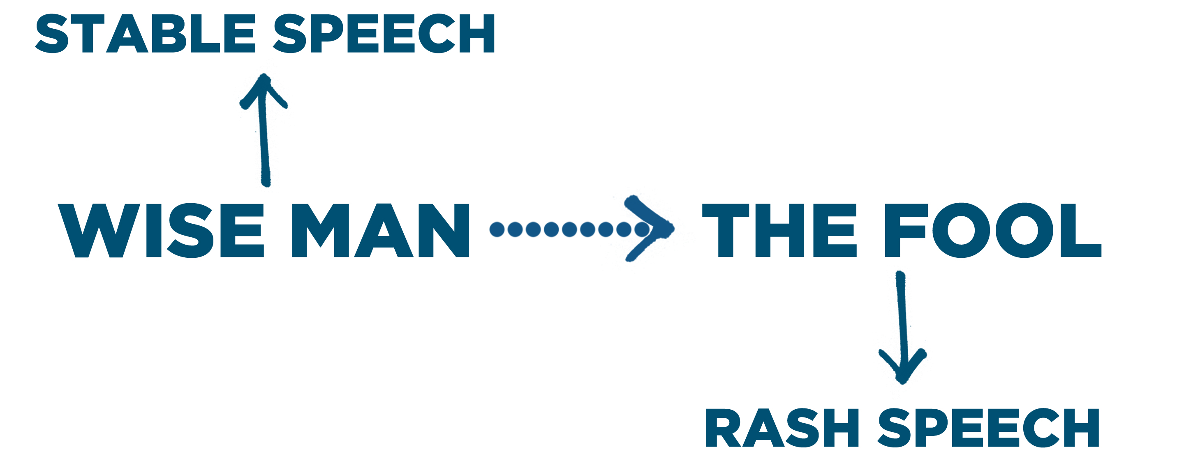
Stable Speech: Speaking because you fear the Lord.
- The fool:
- self-control
- in speech
- The peaceful wise man:
- self control
- in speech

Journey Group Questions
- Spoken and written words have an enormous influence and impact on our lives and the lives of others. Read James 3:3-6 and answer the following questions.
  - What are the two illustrations of verses 3-4, and what do these illustrations say about the role of words and their ability to steer the entire direction of your life?
  - How does the use of words serve as a measure of self-control? On a scale of 1-10 (10 is best), how would you rate your self-control based on your use of words?
  - What is the illustration of verse 5-6, and what is the warning associated with this illustration?
  - Has your own fiery, rash, or hasty speech (spoken or written) ever set your life, or the life of someone else, on fire? How could that speech-wildfire have been avoided?
  - How does fiery-speech contrast with how wise-speech is described in this week’s sermon? (Prov. 21:23; 29:11)?

- Spoken and written words are routinely used for both good and evil, but wise men and women should strive for consistently wise speech. Read James 3:7-12 and answer the following questions.
  - What are the two illustrations of verses 11-12, and what do these illustrations say about the relationship of the heart and speech?
  - Why is it so important to have consistent, grace-filled speech?
  - In what ways does inconsistent, mixed message speech which includes both helpful and harmful words (i.e. social media rants, gossip, hypocrisy, etc.) undermine your testimony as a follower of Christ?
  - What specific steps can you take to stop the flow of harmful words springing forth from your heart?
  - How can you help other people under your influence to do the same?

