Wisdom & Truthful Speech | Prov. 12:19-22; Psalm 15:3-4

Pastor Cky Carrigan | April 2, 2017

Sermon Notes
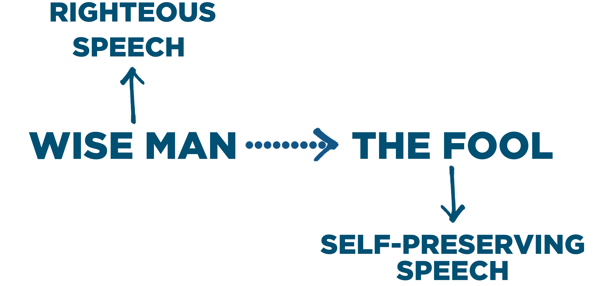
Marks of a wise communicator:
- Wise communicators pursue _______ ________. Prov. 12:22

- Wise communicators pursue ________ ________. Ps. 15

Journey Group Notes
- Read Proverbs 23:23a and Psalms 117:2. In keeping with the general testimony of Scripture, these passages affirm that TRUTH (absolute truth) exists and can be known. Answer the following according to these two passages:

- How do these passages give evidence that TRUTH exists?

- How do these passages give evidence that TRUTH can be known by humans?

- Who is the source of TRUTH according to these passages?

- How valuable is TRUTH according to these passages?

- Any statement may be properly measured by whether, or not, it corresponds with reality (the real and accurate state of things). A TRUE statement corresponds to the way things really are. A false statement does not. In our daily lives, we often make assertions of truth (statements we consider to be true) that do not correspond with reality. For instance, a dad may say, “I spend lots of time with my family,” when in reality he spends much of his time at home watching television while his kids are playing in the other room. List five examples of these kinds of assertions of truth that are often found not to be true (or entirely true) in each of the following areas of our lives.

- Family Relationships

- Marriage Relationship

- Relationship with Christ

- Church/Journey Group Relationships

- Work Relationships

- Speaking the truth, or speaking truthfully, especially when speaking in a corrective or instructive context requires equal measures of truth and love. Read and reflect upon
1 Corinthians 13:1-6, and substitute the words “THE TRUTH” for “with tongues of men and angels” in 13:1. Then, answer the following questions.

  - What does it look like for a person to speak truth without love in a situation? What is generally the result of that kind of conversation and why?

  - What does it look like for a person to speak in love without truth in a situation? What is generally the result of that kind of conversation and why?

  - Most people tend to emphasize one or the other of these. What is your tendency and how can you grow toward a balanced approach to speaking the truth in love this week?

- Consider your daily interactions with others. Are you consistently choosing to purse righteousness in your speech or are you prone to resort to falsehood for the sake of self-preservation? What can you change this week to begin to speak the truth righteously in your daily life?

