Wisdom and a Teachable Spirit | Proverbs 9:7-10

Pastor Bill Curtis | January 29, 2017

Sermon Notes
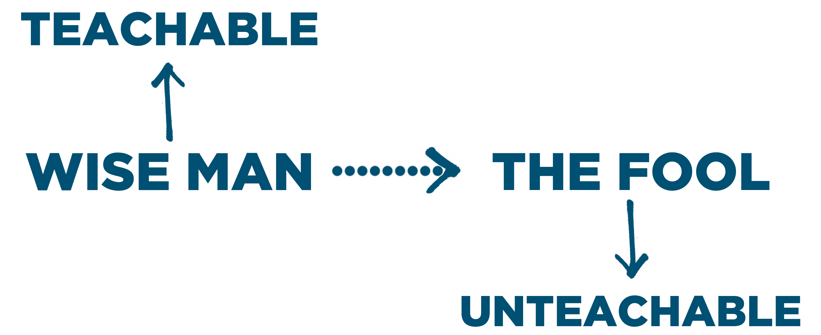
Marks of a teachable spirit:
- Embrace __________

- Embrace __________

- Embrace _________

- Experience __________

Journey Group Questions
- Read Proverbs 9:7-10. A teachable spirit is a necessary trait of the wise man.

  - What happens when you correct a foolish person?

  - When it comes to receiving advice, how is the attitude of a wise man different from to the attitude of a foolish person?

  - What makes being corrected so difficult for a foolish person?

  - On a scale of 1-10, with 10 being the most teachable, how do you rate yourself in being teachable. And, how would the people who closely share life with you rate your teachability?

  - What rewards are given to the wise man who receives correction well?

- Read Proverbs 22:17-21.

  - Since being teachable requires both hearing and applying words of wisdom, what role does listening attentively and carefully play in acquiring wisdom?

  - How much room is there for you to grow in listening more attentively and carefully?

  - Identify two things you can start doing today which will help you listen more attentively and carefully to words of wisdom.

- The main barrier to a teachable attitude is pride. Read Proverbs 11:2 and Romans 12:3-8.

  - What is the remedy for pride?

  - Identify two ways you can cultivate and maintain a more humble, teachable attitude.

