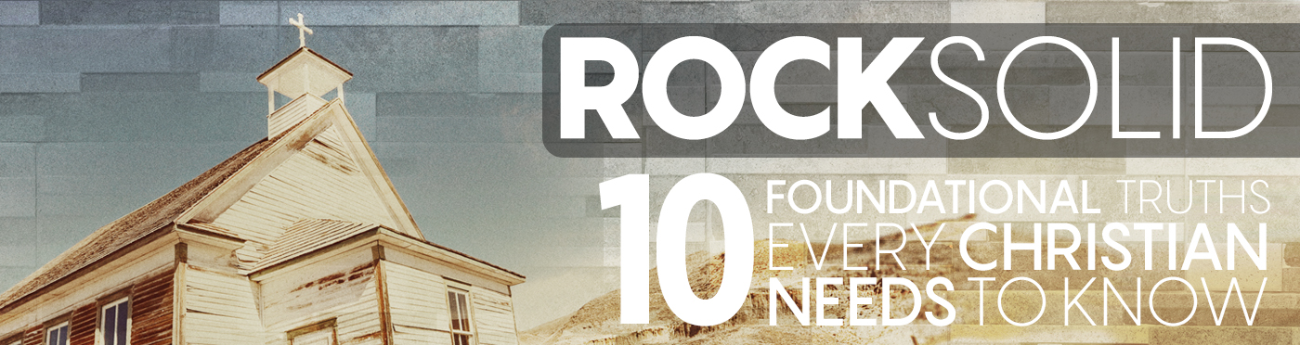

Rock Solid: Embrace Life | Exodus 20:13

Pastor Keith Thompson | November 6, 2016

Sermon Notes
God values all human life and has vested every life with the potential to glorify Him.
- God calls us to ______________ all human life.
  - Protect the _____________ and the _________. Leviticus 19:32; Deuteronomy 24:19-21; 1 Timothy 5:3-8; James 1:27

  - Protect the _______ and the ___________.
Exodus 22:21-27; Leviticus 23:22; Proverbs 14:31;
Psalms 82:3-4; 1 John 3:17-18

  - Protect the ___________.
Exodus 21:22-25; Psalms 139:13-16

- God calls us to ___________ all human life.

- God calls us to maximize the __________ of every human life.

Journey Group Questions
- The principle this week is that “God values all human life and has vested every life with the potential to glorify Him.” Read Genesis 4:1-16 and answer the following:
  - What do we learn regarding the potential God has vested in every life from this story?

  - What were the underlying issues or sinful attitudes and choices that led to the tragic end in this story?

  - How do these same sins influence our view of others and lead to attitudes and actions that devalue others rather than honoring them as image-bearers of God?

  - How do these attitudes or actions prevent us from being missional in our daily lives and being intentional with the gospel of our Lord Jesus Christ?

- God calls us to protect all human life, including the fatherless, aged, poor, oppressed, and unborn. Thinking of these specific categories, how can you become intentionally involved in protecting life in your family, your community, and the world this week and in the future?

- With regard to your family, how are you modeling the value and worth of others for your children or other family members? How are your attitudes or actions devaluing others or reinforcing prejudices?

