Disarming the Enemy

Colossians 2:4-15 November 8, 2015
Emerge Notes

- Remember your roots (Colossians 2:4-8).

- Remember your baptism (Colossians 2:9-14).

- Remember that the enemy has no ammunition (Colossians 2:15).

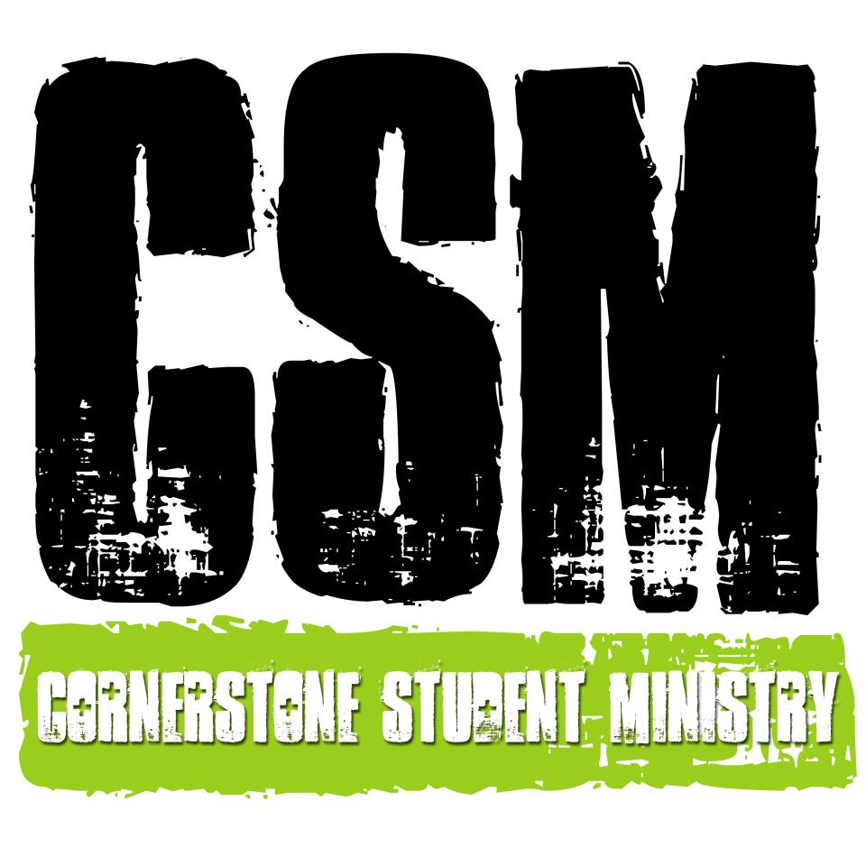

Disarming the Enemy

Colossians 2:4-15 November 8, 2015
CSM Journey Group Questions

- The ancient heresy of Gnosticism basically considered the physical/material world to be sinful, such that the only way to approach or know God was through the mind or spirit. According to Colossians 2:8, how does Paul describe this belief? How is this like other beliefs or philosophies we encounter today?

- We have recently studied the person and work of Christ. How does what the Gnostics believed directly contradict what we have learned about Jesus Christ and why is salvation in Christ impossible if the Gnostics were right?

- Define legalism in a Christian context and share some examples? Next, define license in a Christian context and share some examples. Why are people so prone to lapse into one of these and how do we resist that tendency?

- Summarize Paul’s arguments against legalism for the Christian according to Colossians 2:11-15. How does v. 15 in particular help free us to live a life for Christ’s glory?

The next GIRLS study is Monday, November 16th from
6-8 pm at Mrs. Brandon’s house!

Wednesday nights from 6:30-8:30! Talk to Pastor Keith or Hannah to find out where your Journey Group meets!

