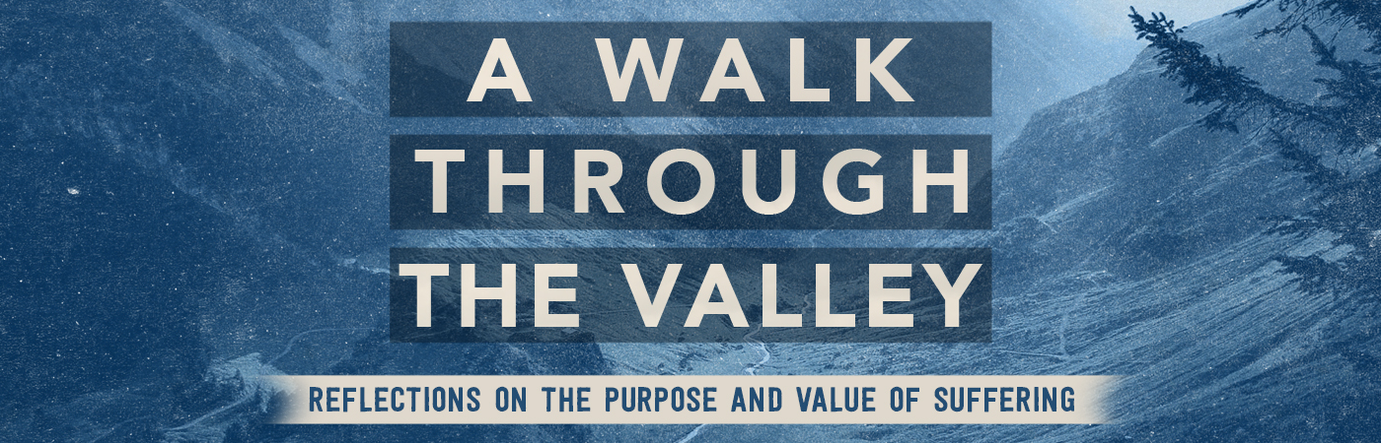

Suffering as Tribulation Part 2 | James 1:1-4

Pastor Bill Curtis | August 6, 2017

Sermon Notes

- God allows suffering in our lives to cultivate spiritual endurance. 1-3

- Spiritual endurance will result in spiritual . 4

Process:
- Acknowledge that God has allowed your suffering for a ;

- Practice faith in God vs. of the suffering;
- Submit to God’s for the suffering; “let it work”
- Rejoice in God’s to work all things for good.

