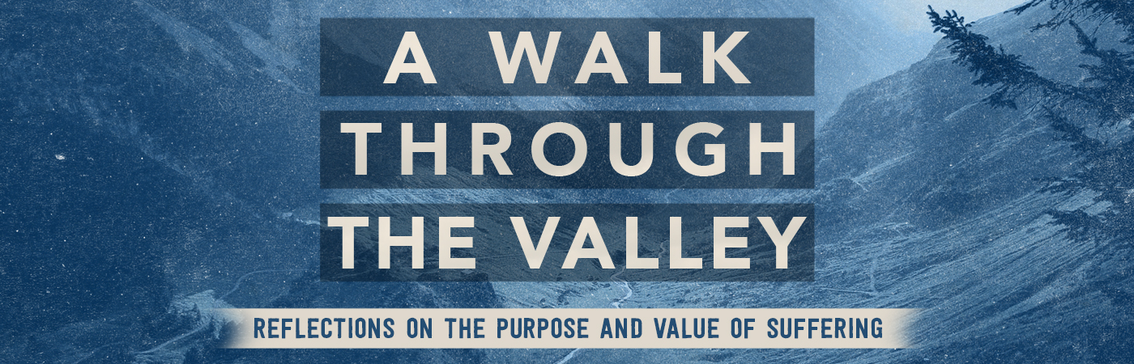

Suffering as Affliction| 2 Corinthians 12:1-10

Pastor Bill Curtis | July 23, 2017

Sermon Notes

God uses suffering in our lives to destroy .
Principles:
- God must Satan to inflict suffering on a person.
- God allows Satan to inflict suffering for a .
- God seldom the source of our suffering.
Response:
- Appeal to the of God (12:8).
- Depend on the of God (12:9a).
- Boast in the of God (12:9b-10).

