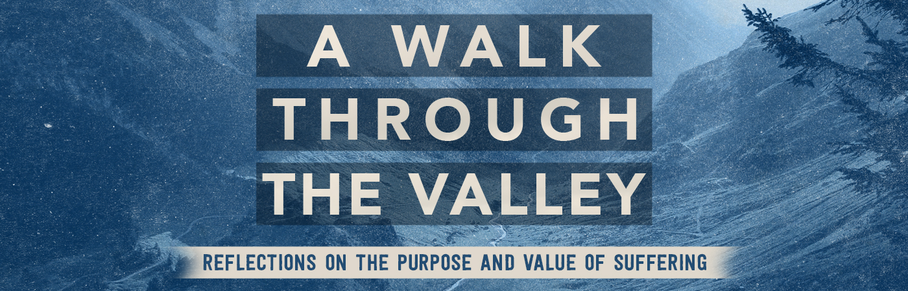

Suffering as Discipline| Hebrews 12:3-13

Pastor Bill Curtis | July 16, 2017

Sermon Notes

God uses suffering in our lives as a form of ___________.

- Discipline is a from God for those who have been adopted into His family (12:3-9).

- Discipline is for those who desire to grow in righteousness (12:10-13).

