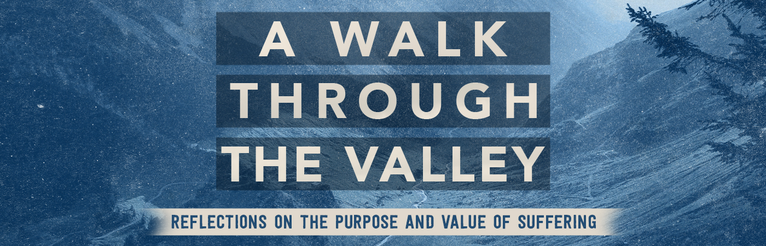

Understanding Suffering| John 9:1-7

Pastor Bill Curtis | July 9, 2017

Sermon Notes

- Where did suffering originate?

- : cursed by God to crawl on the earth until the end of time (Gen 3:14)

- : cursed by God to be crushed by the promised seed of the woman (Gen 3:15)

- : cursed by God to experience pain in childbirth and to chafe under the authority and leadership of her husband (Gen 3:16)

- : cursed by God to yield fruit in competition with thorns and thistles (Gen 3:17-18)

- : cursed by God to a life of back-breaking work in order to provide for himself and his family
(Gen 3:19)

- : cursed by God to die. This was the ultimate punishment for their act of rebellion against God (Gen 2:17)

- If you , you will .

- Suffering is one means for God’s to be revealed through our lives.

