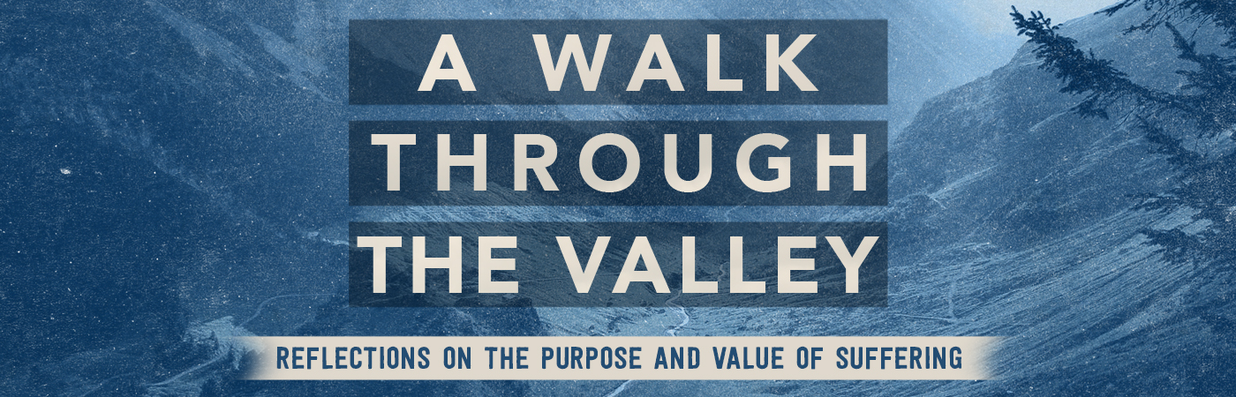

Meeting God on the Mountain | Psalm 121

Pastor Bill Curtis | June 25, 2017

Sermon Notes

- God is our only source of help in seasons of .
- God is in .
- God is always paying .
- God will never let you .

