Wisdom and Money | Proverbs 3:9-10
Pastor Bill Curtis | June 11, 2017

Sermon Notes
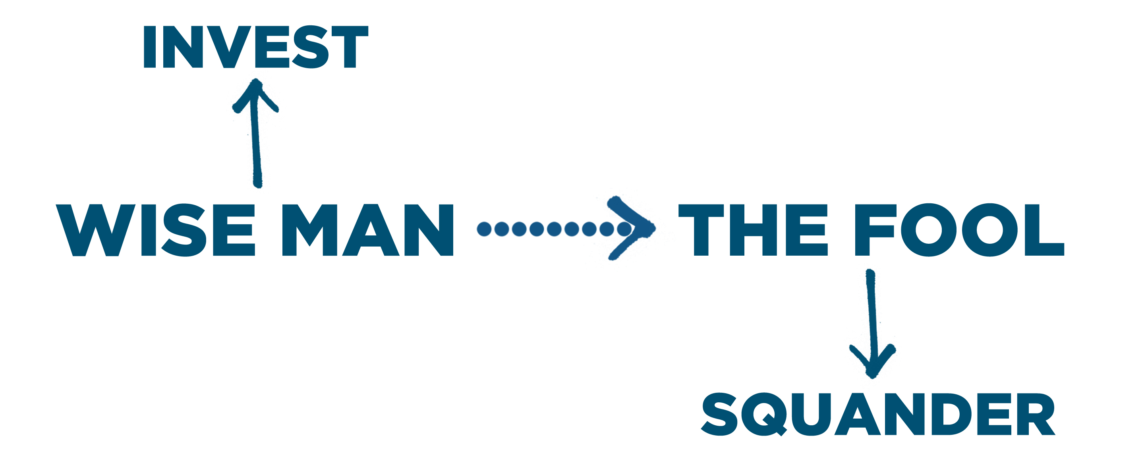

Financial Stewardship: Giving because you fear the Lord.
- Honoring God by investing in His kingdom work is the first for our finances. 9
PROCESS:
- - the first 10% of every dollar you earn
- - voluntary kingdom gifts above your tithe
- Honoring God by investing in His kingdom work results in His . 10

