Wisdom and Hard Work | Proverbs 6:6-11
Pastor Bill Curtis | June 4, 2017

Sermon Notes
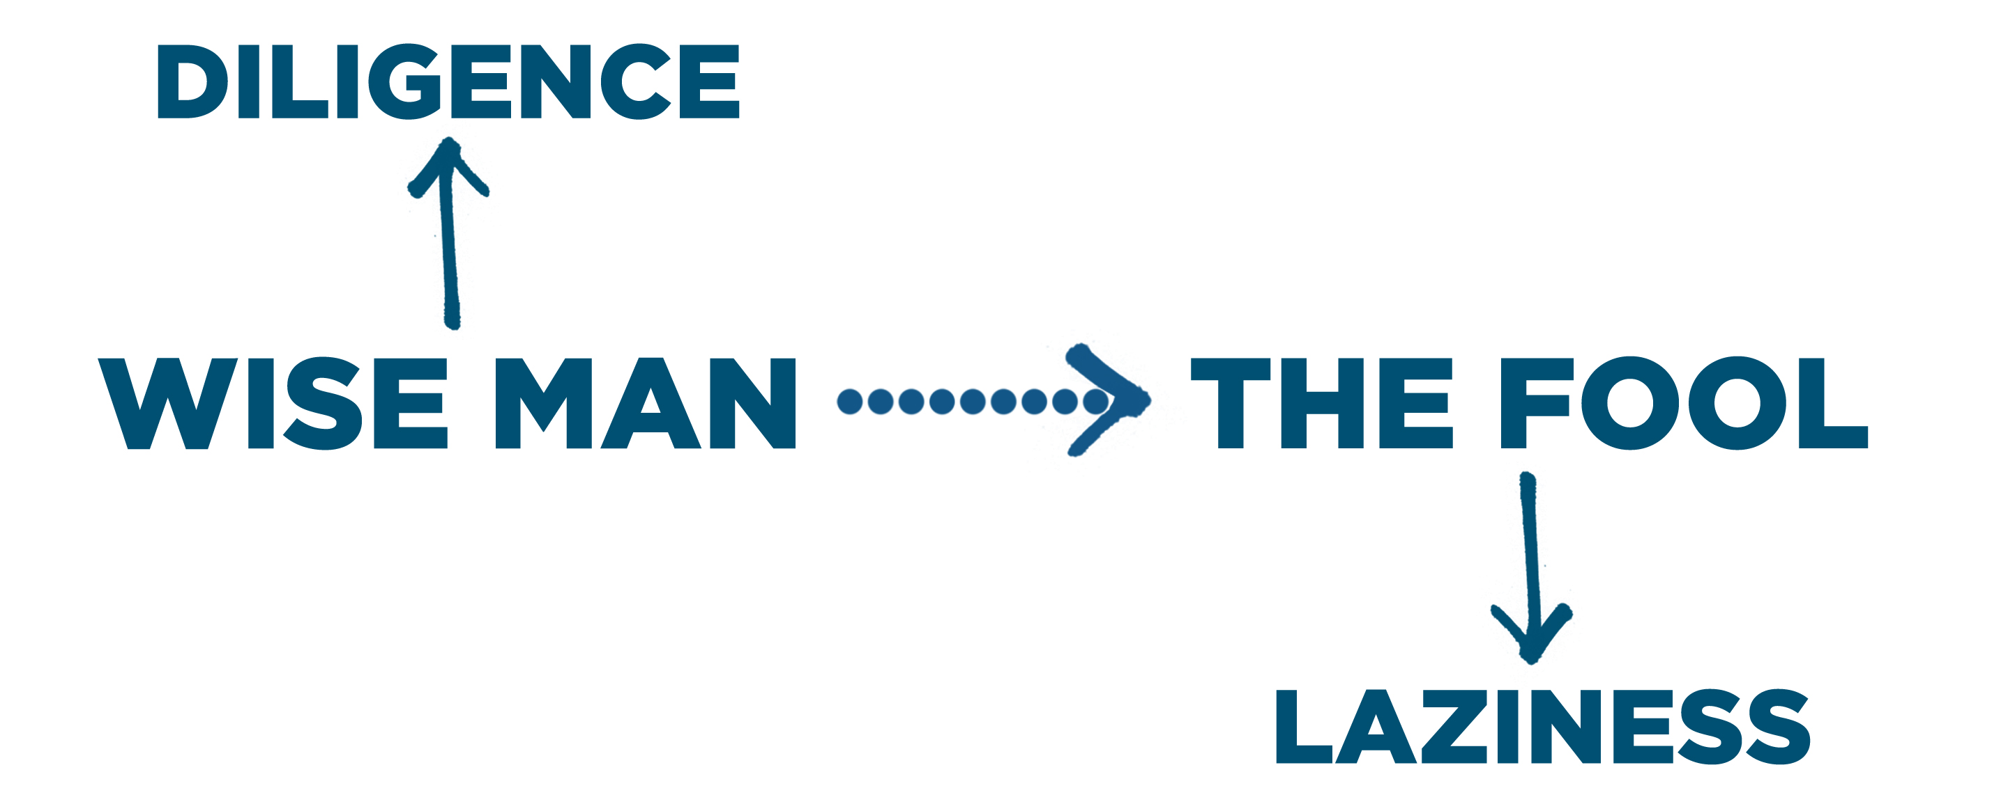

- Diligence: Giving your because you fear the Lord.

- The diligent person is (6-7).

- The diligent person is (8).

- The diligent person is (9-11).

