Wisdom and Goals | Proverbs 16:1-8
Pastor Cky Carrigan | May 28, 2017

Sermon Notes
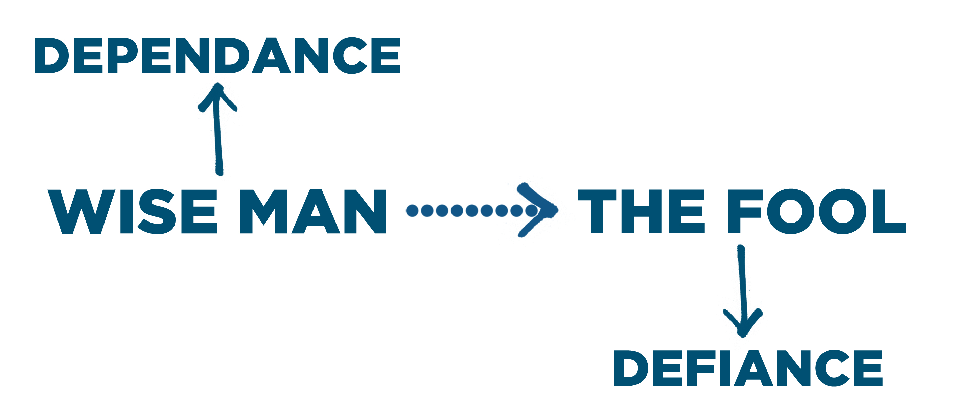

- Dependence means your goals from the LORD, and your goals to the LORD, because you fear the LORD in faith.
Depend on God for…
- Your (16:1)
- Your (16:2)
- Your (16:3-4)
- Your (16:5)
- Your (16:6-8)
- Your (16:9)
Personal Reflection Questions:
Read and reflect upon Ephesians 5:15-17 and Proverbs 16:1-9 together with the sermon for today and answer the following questions during your personal devotion time this week.
- How comfortable are you with the idea that God is sovereign over every area of your life?

- Describe your walk of life over the last six to twelve months with respect to the wisdom of your goals. Has this been a season of high dependence upon God? How well are God’s goals for your life and your goals for your life aligned?

- Identify a couple of specific areas in your life where you may be tempted to defy the LORD and struggle to depend on Him completely. Which of your goals need a bit of adjusting so they align better with God’s goals for you?

- What two specific things will you begin to do today that will help you grow towards trusting the Lord more and depending upon him better in the area of your goals?

Worship
Open Up The Heavens
Vertical Church Band

Lay Me Down
Chris Tomlin
Once For All
Paul Baloche

O Praise The Name (Anastasis)
Hillsong
Called Me Higher
All Sons & Daughters

