Wisdom and Marriage | Proverbs 5:15-23 | Pastor Keith Thompson | March 26, 2017

Sermon Notes
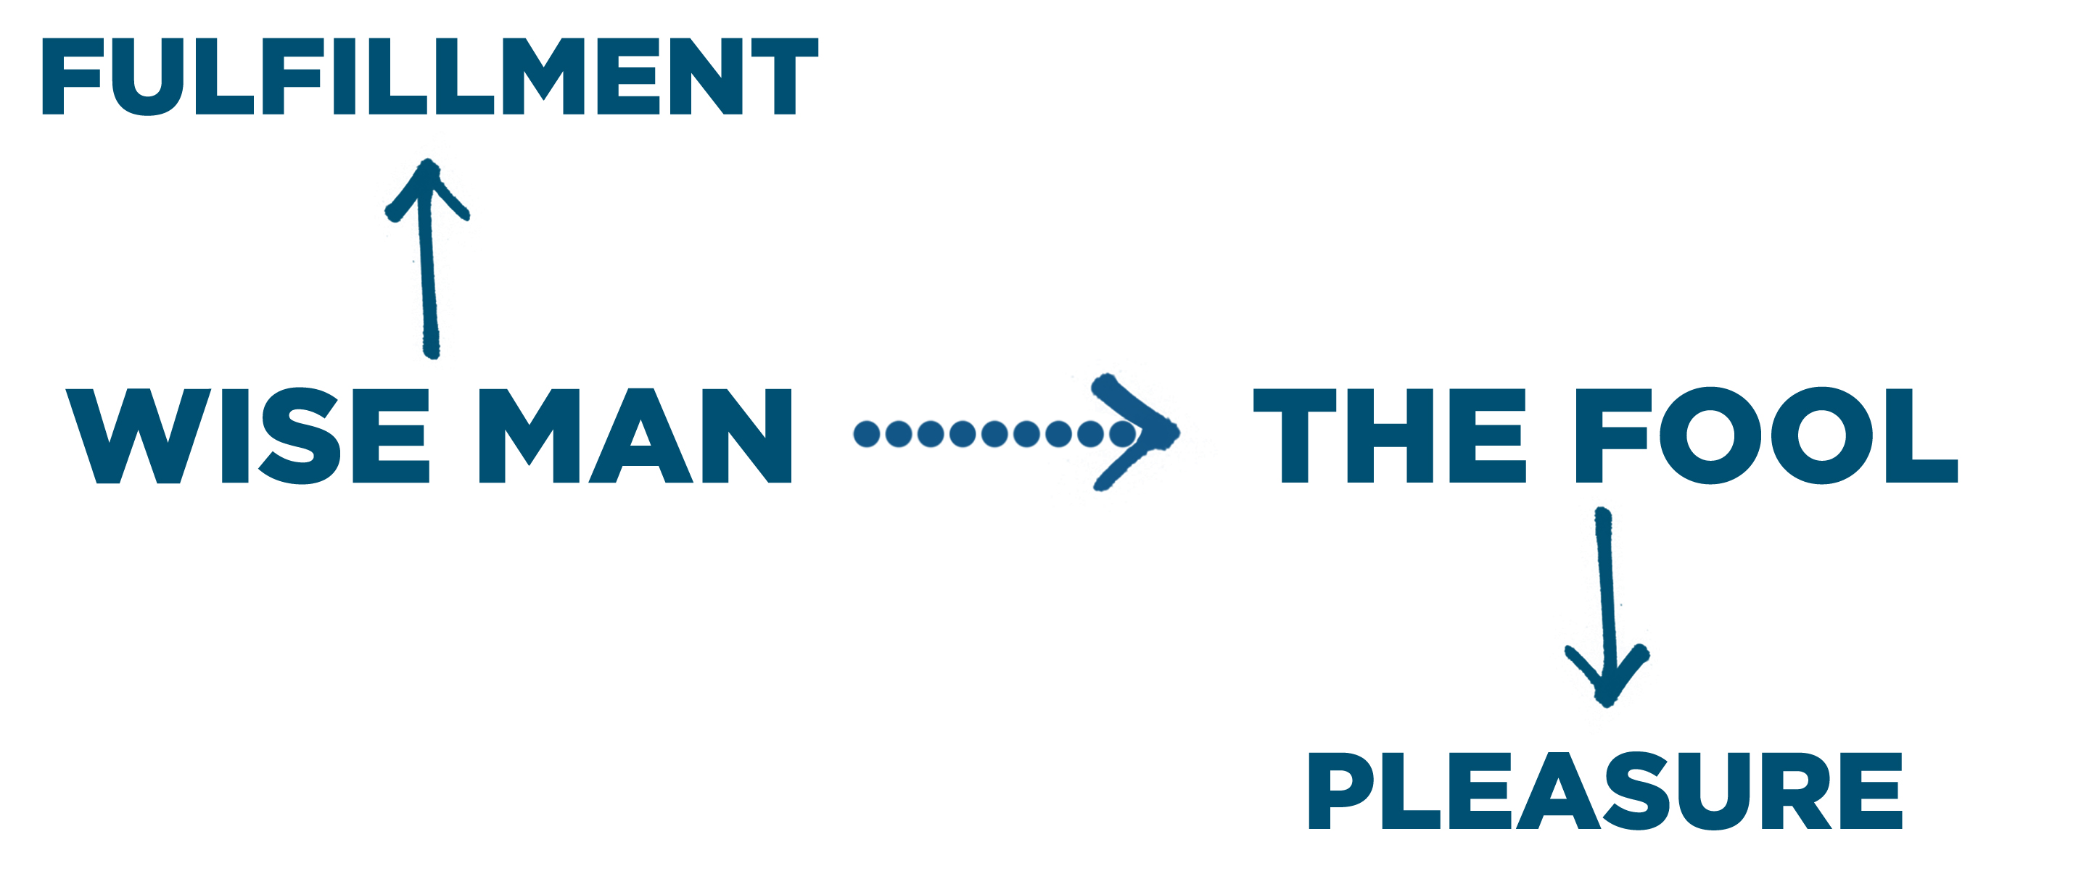
Marks of a wise spouse:
- Wise people wise spouses (5:15-17).
- Wise people in their spouses (5:18).
- Wise people their spouses (5:19).
- Wise people to their spouses (5:20-23).

Journey Group Notes
Humans are designed by God for marriage and for sexual fulfillment in marriage. Read and reflect upon the life-coaching from Proverbs 5:15-23, and answer the following questions.
- Describe the difference between pursuing fulfillment (the wise person) and pursing pleasure (the foolish person) in marriage.

- What problems exist with a worldview that devalues or postpones marriage?’

- Wise people invest in their spouses (Proverbs 5:18), striving to develop healthy, God-honoring marriages, through which they and their spouses can find fulfillment.
  - Read Ephesians 5:33. Why did God specifically command husbands to love their wives and wives to respect their husbands?

  - In what ways do love and respect contribute to the health and stability of a marriage over time?

  - If you are married, what are two or more specific ways that you can more intentionally invest in your spouse this week?

- Wise people enjoy their spouses (Proverbs 5:19), focusing their emotional and sexual affections upon their spouse to find fulfillment in their marriage.
  - If God created human sexuality to be enjoyed in the context of marriage, why is physical intimacy the source of so much conflict in many marriages?

  - How does the biblical emphasis upon fulfillment and contentment help us overcome those struggles?

  - How does sexual immorality (pursuing sexual pleasure outside of marriage) erode intimacy in marriage and ultimately destroy the marriage relationship?

  - What are two ways that you can enjoy your spouse this week and find greater fulfillment in your marriage?

- When our priorities get misplaced, our marriages begin to suffer and we begin to drift away from the fulfillment that comes from a Christ-centered life. Consider the biblical hierarchy of priorities (1. God,
2. Spouse, 3. Family, 4. Career, etc.).
  - In what ways are you successfully maintaining these priorities?

  - In what ways have your priorities gotten out of order and need to be realigned for you and your family to begin to experience biblical fulfillment again?

