Wisdom and Parenting | Proverbs 22:6 & 3:11-12 | Pastor Bill Curtis | March 19, 2017

Sermon Notes
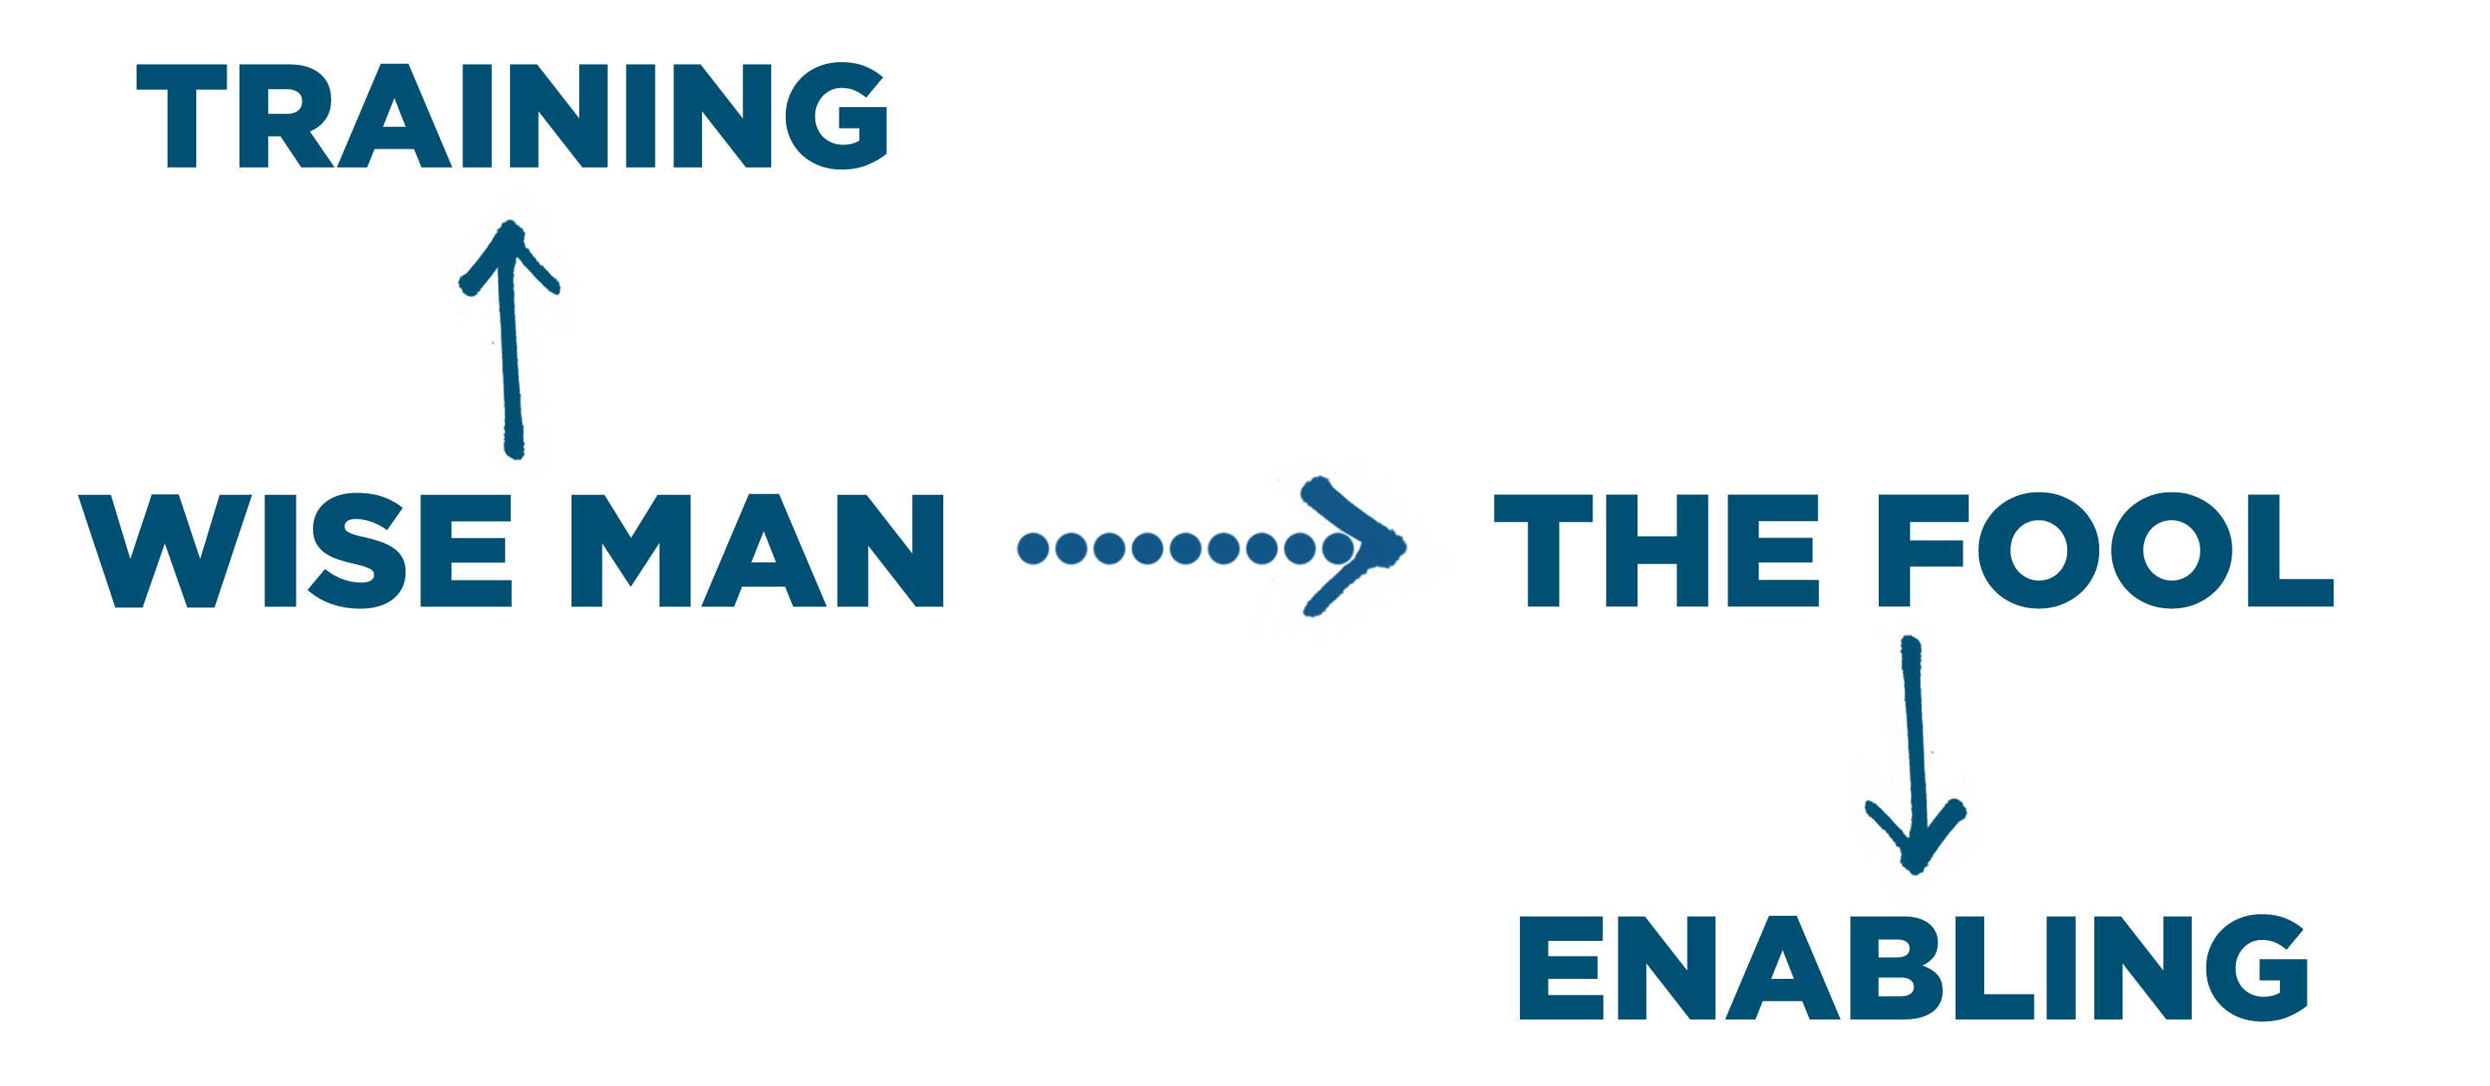
1. Marks of a wise parent:

- Wise parents their children. 22:6
- Wise parents their children. 22:15, 23:13
- Wise parents their children. 29:15; 3:11-12

2. Plans of a wise parent:

- Clearly defined ____________
- Clearly developed ____________
- Clearly delineated ____________
Journey Group Notes
Read and reflect upon these biblical passages and the sermon for March 19 on parenting, then answer the following questions. Proverbs 3:11-12; 22:6,15; 23:13; 29:15; Deuteronomy 6:4-7; Eph 6:1-4. Remember, the parent-child relationship changes over time. Adult children may not be under a parent’s authority once they no longer live in the parent’s household, but there continues to be a discipling role for parents of adult children. And, there is even a discipling role of sorts for adult children with their parents at times.
- Like marriage and friendship, parenting presents an important environment for spiritual development—for the parent, and for the child. How does parenting provide an environment for parents and children, in every stage of this relationship and at every age, to grow in the following wise ways……?

- Teachability (correction and training)
- Parents –
- Children –
- Righteousness (clothed in Christ’s righteousness, behaving righteously)
- Parents –
- Children –
- Graciousness (humility, forgiveness, encouragement)
- Parents –
- Children –
- Peacefulness (gentleness, self-controlled, not-angry)
- Parents –
- Children –

- Wise parents should clearly define their expectations for the children living in their household.

  - What are some examples of poorly defined expectations?

  - What is the value of clearly defined expectations?

  - If you are a parent with children living in your household, what are some expectations you need to define more clearly for your children?

- Wise parents should offer clearly developed explanations for the expectations they convey to the children living in their household.

  - What are some examples of poorly defined explanations?

  - What is the value of clearly defined explanations?

  - If you are a parent with children living in your household, what improvements can you make in the area of better explanations?

- Wise parents should establish clearly delineated consequences for failing to meet the expectations they convey to the children living in their household.

  - What are some examples of unclear, or poorly, devised consequences?

  - What is the value of clearly delineated consequences?

  - If you are a parent with children living in your household, what improvements can you make in the area of stated consequences?

